**Shiro学习--与SpringMVC整合（数据库，Shiro注解和Shiro标签）**

原创 2016年03月09日 18:16:09

* 标签：
* [shiro](http://so.csdn.net/so/search/s.do?q=shiro&t=blog)

关于Shiro的环境搭建和核心概念参考

<http://blog.csdn.net/frankcheng5143/article/details/50815495>

<http://blog.csdn.net/frankcheng5143/article/details/50818198>

通过Shiro官方给的Tutorial我们知道Shiro的操作都是基于Subject的，而Subject来自SecurityManager，如下

SecurityManager securityManager = factory.getInstance();

SecurityUtils.setSecurityManager(securityManager);

// get the currently executing user:

Subject currentUser = SecurityUtils.getSubject();

* 1
* 2
* 3
* 4
* 5

通过[整合之道](http://blog.csdn.net/frankcheng5143/article/category/6114667)我们知道Spring和其他框架的整合就是将其他框架的核心概念通过一个bean交由Spring管理起来，而Shiro的核心概念就是SecurityManager，所以Spring对Shiro的整合就是对SecurityManager的整合。而与SpringMVC的整合是SpringMVC拦截请求的时候还要交给Shiro进行拦截。

先来看一下结果，有个感性的认识，再看细节，直接上图。

没有登录跳转到登录页面，登录后进入刚才输入的页面



不同权限看到的页面



让我们仔细看一下实现细节。

**数据库结构**

参考

<http://blog.csdn.net/chris_mao/article/details/49188699>

<http://blog.csdn.net/chris_mao/article/details/49215471>

总共有五张表，

**用户表，存储用户的相关信息**   
**角色表，存储角色的相关信息**   
**权限表，存储权限的相关信息**   
**用户角色表，存储用户和角色的对应关系 一对多**   
**角色权限表，存储角色和权限的对应关系 一对对**

关系如下

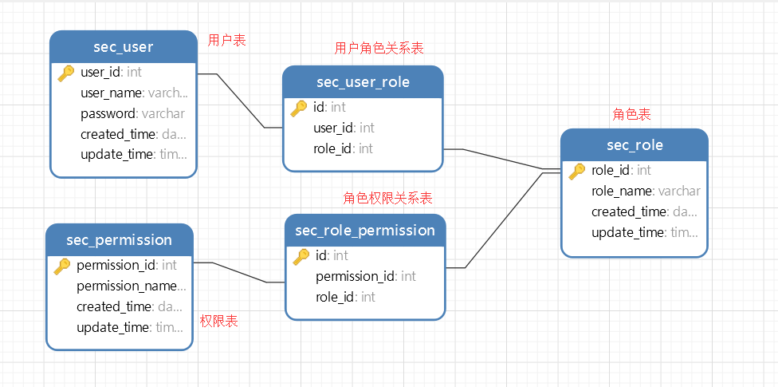

**数据库脚本**

数据库名称为shiro_test

/*

Navicat MySQL Data Transfer

Source Server : 本地连接

Source Server Version : 50620

Source Host : localhost:3306

Source Database : shiro_test

Target Server Type : MYSQL

Target Server Version : 50620

File Encoding : 65001

Date: 2016-03-09 16:50:54

*/

SET FOREIGN_KEY_CHECKS=0;

-- ----------------------------

-- Table structure for sec_permission

-- ----------------------------

DROP TABLE IF EXISTS `sec_permission`;

CREATE TABLE `sec_permission` (

`permission_id` int(10) unsigned NOT NULL AUTO_INCREMENT,

`permission_name` varchar(64) COLLATE utf8_bin DEFAULT NULL,

`created_time` datetime DEFAULT NULL,

`update_time` timestamp NULL DEFAULT CURRENT_TIMESTAMP,

PRIMARY KEY (`permission_id`)

) ENGINE=InnoDB AUTO_INCREMENT=3 DEFAULT CHARSET=utf8 COLLATE=utf8_bin;

-- ----------------------------

-- Table structure for sec_role

-- ----------------------------

DROP TABLE IF EXISTS `sec_role`;

CREATE TABLE `sec_role` (

`role_id` int(10) unsigned NOT NULL AUTO_INCREMENT,

`role_name` varchar(64) COLLATE utf8_bin DEFAULT NULL,

`created_time` datetime DEFAULT NULL,

`update_time` timestamp NULL DEFAULT CURRENT_TIMESTAMP,

PRIMARY KEY (`role_id`)

) ENGINE=InnoDB AUTO_INCREMENT=3 DEFAULT CHARSET=utf8 COLLATE=utf8_bin;

-- ----------------------------

-- Table structure for sec_role_permission

-- ----------------------------

DROP TABLE IF EXISTS `sec_role_permission`;

CREATE TABLE `sec_role_permission` (

`id` int(10) unsigned NOT NULL AUTO_INCREMENT,

`permission_id` int(10) unsigned NOT NULL,

`role_id` int(10) unsigned NOT NULL,

PRIMARY KEY (`id`),

KEY `permission_id外键` (`permission_id`),

KEY `role_id外键1` (`role_id`),

CONSTRAINT `permission_id外键` FOREIGN KEY (`permission_id`) REFERENCES `sec_permission` (`permission_id`) ON DELETE CASCADE ON UPDATE CASCADE,

CONSTRAINT `role_id外键1` FOREIGN KEY (`role_id`) REFERENCES `sec_role` (`role_id`) ON DELETE CASCADE ON UPDATE CASCADE

) ENGINE=InnoDB AUTO_INCREMENT=2 DEFAULT CHARSET=utf8 COLLATE=utf8_bin;

-- ----------------------------

-- Table structure for sec_user

-- ----------------------------

DROP TABLE IF EXISTS `sec_user`;

CREATE TABLE `sec_user` (

`user_id` int(10) unsigned NOT NULL AUTO_INCREMENT,

`user_name` varchar(64) COLLATE utf8_bin DEFAULT NULL,

`password` varchar(128) COLLATE utf8_bin DEFAULT NULL,

`created_time` datetime DEFAULT NULL,

`update_time` timestamp NULL DEFAULT CURRENT_TIMESTAMP,

PRIMARY KEY (`user_id`)

) ENGINE=InnoDB AUTO_INCREMENT=3 DEFAULT CHARSET=utf8 COLLATE=utf8_bin;

-- ----------------------------

-- Table structure for sec_user_role

-- ----------------------------

DROP TABLE IF EXISTS `sec_user_role`;

CREATE TABLE `sec_user_role` (

`id` int(10) unsigned NOT NULL AUTO_INCREMENT,

`user_id` int(10) unsigned DEFAULT NULL,

`role_id` int(10) unsigned DEFAULT NULL,

PRIMARY KEY (`id`),

KEY `user_id外键` (`user_id`),

KEY `role_id外键` (`role_id`),

CONSTRAINT `role_id外键` FOREIGN KEY (`role_id`) REFERENCES `sec_role` (`role_id`) ON DELETE CASCADE ON UPDATE CASCADE,

CONSTRAINT `user_id外键` FOREIGN KEY (`user_id`) REFERENCES `sec_user` (`user_id`) ON DELETE CASCADE ON UPDATE CASCADE

) ENGINE=InnoDB AUTO_INCREMENT=3 DEFAULT CHARSET=utf8 COLLATE=utf8_bin;

* 1
* 2
* 3
* 4
* 5
* 6
* 7
* 8
* 9
* 10
* 11
* 12
* 13
* 14
* 15
* 16
* 17
* 18
* 19
* 20
* 21
* 22
* 23
* 24
* 25
* 26
* 27
* 28
* 29
* 30
* 31
* 32
* 33
* 34
* 35
* 36
* 37
* 38
* 39
* 40
* 41
* 42
* 43
* 44
* 45
* 46
* 47
* 48
* 49
* 50
* 51
* 52
* 53
* 54
* 55
* 56
* 57
* 58
* 59
* 60
* 61
* 62
* 63
* 64
* 65
* 66
* 67
* 68
* 69
* 70
* 71
* 72
* 73
* 74
* 75
* 76
* 77
* 78
* 79
* 80
* 81
* 82
* 83
* 84

**初始数据**

**用户表sec_user**

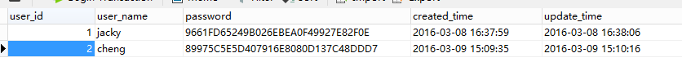

INSERT INTO `sec_user` VALUES ('1', 'jacky', '9661FD65249B026EBEA0F49927E82F0E', '2016-03-08 16:37:59', '2016-03-08 16:38:06');

INSERT INTO `sec_user` VALUES ('2', 'cheng', '89975C5E5D407916E8080D137C48DDD7', '2016-03-09 15:09:35', '2016-03-09 15:10:16');

* 1
* 2

用户jacky密码jacky   
用户cheng密码cheng

**角色表sec_role**

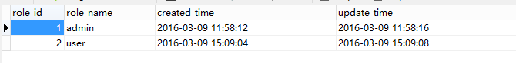

INSERT INTO `sec_role` VALUES ('1', 'admin', '2016-03-09 11:58:12', '2016-03-09 11:58:16');

INSERT INTO `sec_role` VALUES ('2', 'user', '2016-03-09 15:09:04', '2016-03-09 15:09:08');

* 1
* 2

两种角色admin和user

**权限表sec_permission**

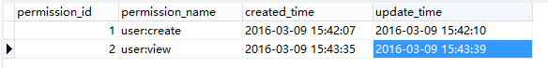

INSERT INTO `sec_permission` VALUES ('1', 'user:create', '2016-03-09 15:42:07', '2016-03-09 15:42:10');

INSERT INTO `sec_permission` VALUES ('2', 'user:view', '2016-03-09 15:43:35', '2016-03-09 15:43:39');

* 1
* 2

两种权限，创建用户user:create和查看用户user:view

**情景**

用户jacky属于admin组，admin拥有创建用户user:create和查看用户user:view权限   
用户cheng输入user组，user组拥有查看用户user:view权限

**用户角色表sec_user_role**

INSERT INTO `sec_user_role` VALUES ('1', '1', '1');

INSERT INTO `sec_user_role` VALUES ('2', '2', '2');

* 1
* 2

**角色权限表sec_role_permission**

INSERT INTO `sec_role_permission` VALUES ('1', '1', '1');

INSERT INTO `sec_role_permission` VALUES ('2', '2', '1');

INSERT INTO `sec_role_permission` VALUES ('3', '2', '2');

* 1
* 2
* 3

**与Spring整合**

首先需要一个SpringMVC，参考

<http://blog.csdn.net/frankcheng5143/article/details/50512340>

整合参考

<http://shiro.apache.org/spring.html>

首先在web.xml中定义shiro的过滤器

**配置web.xml**

web.xml

<!-- shiro的filter-->

<filter>

<filter-name>shiroFilter</filter-name>

<filter-class>org.springframework.web.filter.DelegatingFilterProxy</filter-class>

<init-param>

<param-name>targetFilterLifecycle</param-name>

<param-value>true</param-value>

</init-param>

</filter>

<!-- shiro的filter-mapping-->

<filter-mapping>

<filter-name>shiroFilter</filter-name>

<url-pattern>/*</url-pattern>

</filter-mapping>

* 1
* 2
* 3
* 4
* 5
* 6
* 7
* 8
* 9
* 10
* 11
* 12
* 13
* 14
* 15

完整的web.xml

web.xml

<!DOCTYPE web-app PUBLIC

"-//Sun Microsystems, Inc.//DTD Web Application 2.3//EN"

"http://java.sun.com/dtd/web-app_2_3.dtd" >

<web-app>

<display-name>Archetype Created Web Application</display-name>

<!-- spring核心的位置-->

<context-param>

<param-name>contextConfigLocation</param-name>

<param-value>classpath:spring/spring-core.xml</param-value>

</context-param>

<!-- 统一编码filter -->

<filter>

<filter-name>charsetEncoding</filter-name>

<filter-class>org.springframework.web.filter.CharacterEncodingFilter</filter-class>

<init-param>

<param-name>encoding</param-name>

<param-value>UTF-8</param-value>

</init-param>

<init-param>

<param-name>forceEncoding</param-name>

<param-value>true</param-value>

</init-param>

</filter>

<!-- shiro的filter-->

<filter>

<filter-name>shiroFilter</filter-name>

<filter-class>org.springframework.web.filter.DelegatingFilterProxy</filter-class>

<init-param>

<param-name>targetFilterLifecycle</param-name>

<param-value>true</param-value>

</init-param>

</filter>

<!-- 统一编码的filter-mapping-->

<filter-mapping>

<filter-name>charsetEncoding</filter-name>

<url-pattern>/*</url-pattern>

</filter-mapping>

<!-- shiro的filter-mapping-->

<filter-mapping>

<filter-name>shiroFilter</filter-name>

<url-pattern>/*</url-pattern>

</filter-mapping>

<!-- 此监听器出用于主要为了解决java.beans.Introspector导致内存泄漏的问题. This listener should

be registered as the first one in web.xml, before any application listeners

such as Spring's ContextLoaderListener. -->

<listener>

<listener-class>org.springframework.web.util.IntrospectorCleanupListener</listener-class>

</listener>

<!-- 加载spring核心的listener-->

<listener>

<listener-class>org.springframework.web.context.ContextLoaderListener</listener-class>

</listener>

<!-- springmvc前端控制器配置 -->

<servlet>

<servlet-name>mvc</servlet-name>

<servlet-class>org.springframework.web.servlet.DispatcherServlet</servlet-class>

<init-param>

<param-name>contextConfigLocation</param-name>

<param-value>classpath:/spring/spring-mvc.xml</param-value>

</init-param>

<load-on-startup>1</load-on-startup>

</servlet>

<servlet-mapping>

<servlet-name>mvc</servlet-name>

<url-pattern>/</url-pattern>

</servlet-mapping>

</web-app>

* 1
* 2
* 3
* 4
* 5
* 6
* 7
* 8
* 9
* 10
* 11
* 12
* 13
* 14
* 15
* 16
* 17
* 18
* 19
* 20
* 21
* 22
* 23
* 24
* 25
* 26
* 27
* 28
* 29
* 30
* 31
* 32
* 33
* 34
* 35
* 36
* 37
* 38
* 39
* 40
* 41
* 42
* 43
* 44
* 45
* 46
* 47
* 48
* 49
* 50
* 51
* 52
* 53
* 54
* 55
* 56
* 57
* 58
* 59
* 60
* 61
* 62
* 63
* 64
* 65
* 66
* 67
* 68
* 69
* 70
* 71
* 72
* 73
* 74
* 75
* 76
* 77
* 78
* 79
* 80
* 81

**配置Bean**

其次在Spring的配置文件中定义各种bean

这里新建一个Spring配置文件spring-shiro.xml

结构如下

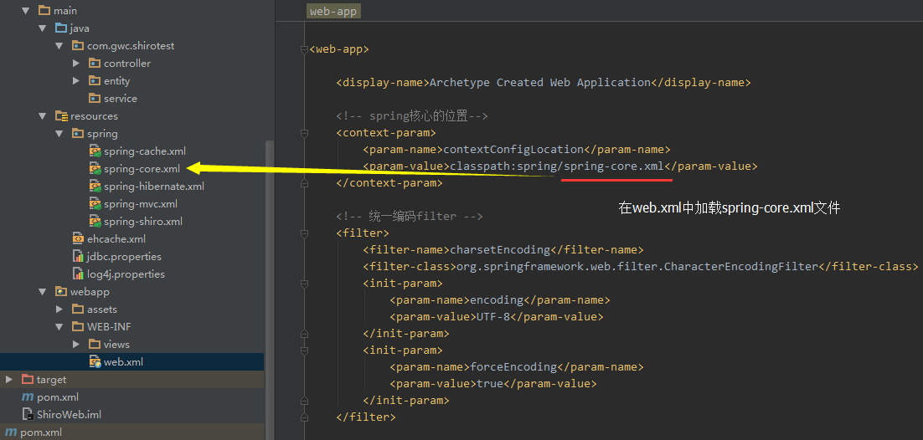

在web.xml中加载spring的时候会加载springmvc的xml，spring-mvc.xml   
和spring的核心配置文件spring-core.xml

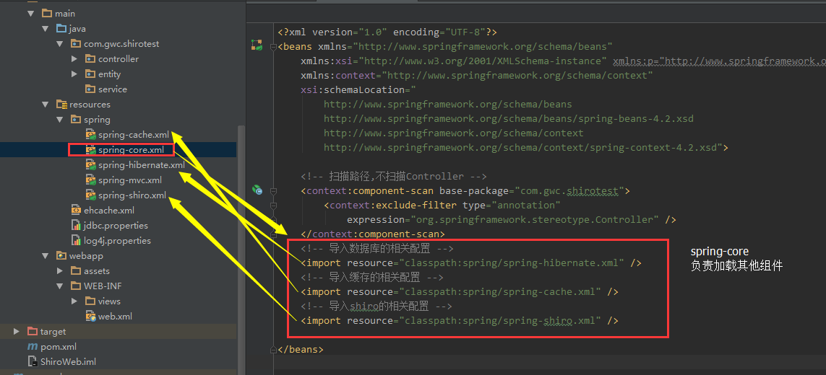

再由spring负责加载其他配置文件

关于缓存和hibernate请参考以下文章

[Spring文档学习–缓存（Cache Abstraction）](http://blog.csdn.net/frankcheng5143/article/details/50791757)

[整合之道–Spring4整合Ehcache2.10](http://blog.csdn.net/frankcheng5143/article/details/50776542)

[整合之道–Spring4整合Hibernate5](http://blog.csdn.net/frankcheng5143/article/details/50634487)

接下来看一下spring-shiro的详细配置

**spring-shiro.xml**

<?xml version="1.0" encoding="UTF-8"?>

<beans xmlns="http://www.springframework.org/schema/beans"

xmlns:xsi="http://www.w3.org/2001/XMLSchema-instance"

xsi:schemaLocation="

http://www.springframework.org/schema/beans

http://www.springframework.org/schema/beans/spring-beans-4.2.xsd">

<!-- 导入数据库的相关配置 -->

<import resource="classpath:spring/spring-hibernate.xml"/>

<!-- 对应于web.xml中配置的那个shiroFilter -->

<bean id="shiroFilter" class="org.apache.shiro.spring.web.ShiroFilterFactoryBean">

<!-- Shiro的核心安全接口，这个属性是必须的 -->

<property name="securityManager" ref="securityManager"/>

<!-- 要求登录时的链接(登录页面地址)，非必须的属性，默认会自动寻找Web工程根目录下的"/login.jsp"页面 -->

<property name="loginUrl" value="/login.html"/>

<!-- 登录成功后要跳转的连接(本例中此属性用不到，因为登录成功后的处理逻辑在LoginController里硬编码) -->

<!-- <property name="successUrl" value="/" ></property> -->

<!-- 用户访问未对其授权的资源时，所显示的连接 -->

<property name="unauthorizedUrl" value="/error/unauthorized"/>

<property name="filterChainDefinitions">

<value>

/admin/**=authc

</value>

</property>

</bean>

<bean id="lifecycleBeanPostProcessor" class="org.apache.shiro.spring.LifecycleBeanPostProcessor"></bean>

<!-- 数据库保存的密码是使用MD5算法加密的，所以这里需要配置一个密码匹配对象 -->

<bean id="credentialsMatcher" class="org.apache.shiro.authc.credential.Md5CredentialsMatcher"></bean>

<!-- 缓存管理 -->

<bean id="shiroCacheManager" class="org.apache.shiro.cache.MemoryConstrainedCacheManager"></bean>

<!--

使用Shiro自带的JdbcRealm类

指定密码匹配所需要用到的加密对象

指定存储用户、角色、权限许可的数据源及相关查询语句

-->

<bean id="jdbcRealm" class="org.apache.shiro.realm.jdbc.JdbcRealm">

<property name="credentialsMatcher" ref="credentialsMatcher"></property>

<property name="permissionsLookupEnabled" value="true"></property>

<property name="dataSource" ref="dataSource"></property>

<property name="authenticationQuery"

value="SELECT password FROM sec_user WHERE user_name = ?"></property>

<property name="userRolesQuery"

value="SELECT role_name from sec_user_role left join sec_role using(role_id) left join sec_user using(user_id) WHERE user_name = ?"></property>

<property name="permissionsQuery"

value="SELECT permission_name FROM sec_role_permission left join sec_role using(role_id) left join sec_permission using(permission_id) WHERE role_name = ?"></property>

</bean>

<!-- Shiro安全管理器 -->

<bean id="securityManager" class="org.apache.shiro.web.mgt.DefaultWebSecurityManager">

<property name="realm" ref="jdbcRealm"></property>

<property name="cacheManager" ref="shiroCacheManager"></property>

</bean>

<!-- Shiro的注解配置一定要放在spring-mvc中 -->

</beans>

* 1
* 2
* 3
* 4
* 5
* 6
* 7
* 8
* 9
* 10
* 11
* 12
* 13
* 14
* 15
* 16
* 17
* 18
* 19
* 20
* 21
* 22
* 23
* 24
* 25
* 26
* 27
* 28
* 29
* 30
* 31
* 32
* 33
* 34
* 35
* 36
* 37
* 38
* 39
* 40
* 41
* 42
* 43
* 44
* 45
* 46
* 47
* 48
* 49
* 50
* 51
* 52
* 53
* 54
* 55
* 56
* 57
* 58
* 59
* 60
* 61
* 62
* 63

为了开启Shiro注解，**必须在spring-mvc.xml中配置，在其他配置文件中不生效**

spring-mvc.xml

<?xml version="1.0" encoding="UTF-8"?>

<beans xmlns="http://www.springframework.org/schema/beans"

xmlns:xsi="http://www.w3.org/2001/XMLSchema-instance" xmlns:p="http://www.springframework.org/schema/p"

xmlns:context="http://www.springframework.org/schema/context"

xmlns:mvc="http://www.springframework.org/schema/mvc"

xsi:schemaLocation="

http://www.springframework.org/schema/beans

http://www.springframework.org/schema/beans/spring-beans-4.2.xsd

http://www.springframework.org/schema/context

http://www.springframework.org/schema/context/spring-context-4.2.xsd

http://www.springframework.org/schema/mvc

http://www.springframework.org/schema/mvc/spring-mvc-4.2.xsd">

<!-- 导入shiro的相关配置 -->

<import resource="classpath:spring/spring-shiro.xml" />

<!-- 配置扫描路径 -->

<context:component-scan base-package="com.gwc.shirotest.controller" />

<!-- 配置根视图 -->

<mvc:view-controller path="/" view-name="index"/>

<!-- 开启@MatrixVariable注解 -->

<mvc:annotation-driven enable-matrix-variables="true">

</mvc:annotation-driven>

<!-- 激活基于注解的配置 @RequestMapping, @ExceptionHandler,数据绑定 ,@NumberFormat ,

@DateTimeFormat ,@Controller ,@Valid ,@RequestBody ,@ResponseBody等 -->

<!-- <mvc:annotation-driven /> -->

<!-- 图片,css,js等静态资源配置 -->

<mvc:resources location="/assets/" mapping="/assets/**"/>

<!-- jsp视图层配置 -->

<bean id="viewResolver"

class="org.springframework.web.servlet.view.InternalResourceViewResolver">

<property name="viewClass"

value="org.springframework.web.servlet.view.JstlView"/>

<property name="prefix" value="/WEB-INF/views/"/>

<property name="suffix" value=".jsp"/>

</bean>

<!-- 文件上传的bean 10*1024*1024 10M -->

<bean id="multipartResolver" class="org.springframework.web.multipart.commons.CommonsMultipartResolver"

p:defaultEncoding="UTF-8"

p:maxUploadSize="10485760"

p:resolveLazily="true"/>

<!-- 开启shiro注解-->

<bean class="org.springframework.aop.framework.autoproxy.DefaultAdvisorAutoProxyCreator"

depends-on="lifecycleBeanPostProcessor">

<property name="proxyTargetClass" value="true" />

</bean>

<bean class="org.apache.shiro.spring.security.interceptor.AuthorizationAttributeSourceAdvisor">

<property name="securityManager" ref="securityManager"/>

</bean>

</beans>

* 1
* 2
* 3
* 4
* 5
* 6
* 7
* 8
* 9
* 10
* 11
* 12
* 13
* 14
* 15
* 16
* 17
* 18
* 19
* 20
* 21
* 22
* 23
* 24
* 25
* 26
* 27
* 28
* 29
* 30
* 31
* 32
* 33
* 34
* 35
* 36
* 37
* 38
* 39
* 40
* 41
* 42
* 43
* 44
* 45
* 46
* 47
* 48
* 49
* 50
* 51
* 52
* 53
* 54
* 55
* 56
* 57
* 58
* 59

最后两个bean就是配置启用shiro注解的bean，和官方文档中有点不一样

<property name="proxyTargetClass" value="true" />

* 1
* 2

如果不配置这个，注解也是开不了的

**开发Controller**

**登录相关**

ShiroController.java

package com.gwc.shirotest.controller;

import com.gwc.shirotest.entity.User;

import org.apache.log4j.Logger;

import org.apache.shiro.SecurityUtils;

import org.apache.shiro.authc.*;

import org.apache.shiro.authz.UnauthorizedException;

import org.apache.shiro.subject.Subject;

import org.apache.shiro.web.util.SavedRequest;

import org.apache.shiro.web.util.WebUtils;

import org.springframework.stereotype.Controller;

import org.springframework.ui.Model;

import org.springframework.web.bind.annotation.RequestMapping;

import org.springframework.web.bind.annotation.RequestMethod;

import javax.servlet.http.HttpServletRequest;

/**

* Created by GWCheng on 2016/3/8.

*/

@Controller

public class ShiroController {

private static final Logger logger = Logger.getLogger(ShiroController.class);

@RequestMapping(value="/login.html",method=RequestMethod.GET)

public String login(){

logger.info("======用户进入了ShiroController的/login.html");

return "login";

}

@RequestMapping(value = "/logout.html")

public String doLogout(HttpServletRequest request, Model model) {

logger.info("======用户"+request.getSession().getAttribute("user")+"退出了系统");

SecurityUtils.getSubject().logout();

return "redirect:login.html";

}

@RequestMapping(value="/doLogin.html",method=RequestMethod.POST)

public String doLogin(User user,HttpServletRequest request, Model model){

logger.info("======用户进入了ShiroController的/doLogin.html");

String msg ;

UsernamePasswordToken token = new UsernamePasswordToken(user.getUsername(), user.getPassword());

token.setRememberMe(true);

Subject subject = SecurityUtils.getSubject();

try {

subject.login(token);

if (subject.isAuthenticated()) {

request.getSession().setAttribute("user",user);

SavedRequest savedRequest = WebUtils.getSavedRequest(request);

// 获取保存的URL

if (savedRequest == null || savedRequest.getRequestUrl() == null) {

return "admin/home";

} else {

//String url = savedRequest.getRequestUrl().substring(12, savedRequest.getRequestUrl().length());

return "forward:" + savedRequest.getRequestUrl();

}

} else {

return "login";

}

} catch (IncorrectCredentialsException e) {

msg = "登录密码错误. Password for account " + token.getPrincipal() + " was incorrect.";

model.addAttribute("message", msg);

System.out.println(msg);

} catch (ExcessiveAttemptsException e) {

msg = "登录失败次数过多";

model.addAttribute("message", msg);

System.out.println(msg);

} catch (LockedAccountException e) {

msg = "帐号已被锁定. The account for username " + token.getPrincipal() + " was locked.";

model.addAttribute("message", msg);

System.out.println(msg);

} catch (DisabledAccountException e) {

msg = "帐号已被禁用. The account for username " + token.getPrincipal() + " was disabled.";

model.addAttribute("message", msg);

System.out.println(msg);

} catch (ExpiredCredentialsException e) {

msg = "帐号已过期. the account for username " + token.getPrincipal() + " was expired.";

model.addAttribute("message", msg);

System.out.println(msg);

} catch (UnknownAccountException e) {

msg = "帐号不存在. There is no user with username of " + token.getPrincipal();

model.addAttribute("message", msg);

System.out.println(msg);

} catch (UnauthorizedException e) {

msg = "您没有得到相应的授权！" + e.getMessage();

model.addAttribute("message", msg);

System.out.println(msg);

}

return "login";

}

}

* 1
* 2
* 3
* 4
* 5
* 6
* 7
* 8
* 9
* 10
* 11
* 12
* 13
* 14
* 15
* 16
* 17
* 18
* 19
* 20
* 21
* 22
* 23
* 24
* 25
* 26
* 27
* 28
* 29
* 30
* 31
* 32
* 33
* 34
* 35
* 36
* 37
* 38
* 39
* 40
* 41
* 42
* 43
* 44
* 45
* 46
* 47
* 48
* 49
* 50
* 51
* 52
* 53
* 54
* 55
* 56
* 57
* 58
* 59
* 60
* 61
* 62
* 63
* 64
* 65
* 66
* 67
* 68
* 69
* 70
* 71
* 72
* 73
* 74
* 75
* 76
* 77
* 78
* 79
* 80
* 81
* 82
* 83
* 84
* 85
* 86
* 87
* 88
* 89
* 90
* 91

**权限相关**

AdminController.java

package com.gwc.shirotest.controller;

import org.apache.shiro.authz.annotation.Logical;

import org.apache.shiro.authz.annotation.RequiresPermissions;

import org.apache.shiro.authz.annotation.RequiresRoles;

import org.springframework.stereotype.Controller;

import org.springframework.web.bind.annotation.RequestMapping;

/**

* Created by GWCheng on 2016/3/8.

*/

@Controller

public class AdminController {

// 登录成功的页面

@RequestMapping(value = "/admin/home")

public String adminHomePage(){

return "admin/home";

}

// 只有角色为admin的才能访问

@RequiresRoles("admin")

@RequestMapping(value = "/admin/role")

public String adminWithRole(){

return "admin/withrole";

}

// 只用同时具有user:view和user:create权限才能访问

@RequiresPermissions(value={"user:view","user:create"}, logical= Logical.AND)

@RequestMapping(value = "/admin/auth")

public String adminWithAuth(){

return "admin/withauth";

}

}

* 1
* 2
* 3
* 4
* 5
* 6
* 7
* 8
* 9
* 10
* 11
* 12
* 13
* 14
* 15
* 16
* 17
* 18
* 19
* 20
* 21
* 22
* 23
* 24
* 25
* 26
* 27
* 28
* 29
* 30
* 31
* 32
* 33
* 34

**开发页面**

结构

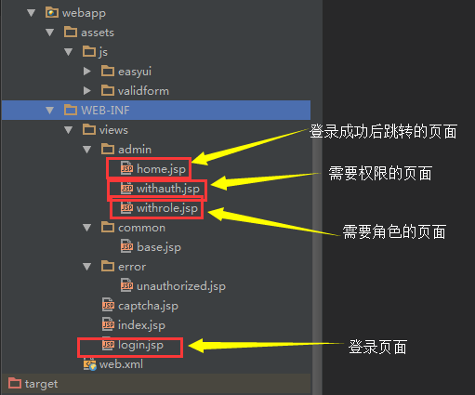

登录页面

login.jsp

<%@ page language="java" contentType="text/html; charset=UTF-8"

pageEncoding="UTF-8"%>

<%@ taglib uri="http://java.sun.com/jsp/jstl/core" prefix="c"%>

<%@ page isELIgnored="false" %>

<!DOCTYPE html PUBLIC "-//W3C//DTD HTML 4.01 Transitional//EN" "http://www.w3.org/TR/html4/loose.dtd">

<html>

<head>

<meta http-equiv="Content-Type" content="text/html; charset=UTF-8">

<title>hello</title>

<c:catch var="importError0">

<c:import url="common/base.jsp" charEncoding="utf-8"></c:import>

</c:catch>

<c:out value="${importError0}"></c:out>

</head>

<body>

<h1>login page</h1>

<form action="<c:url value='/doLogin.html'/>" method="POST">

<label>User Name</label>

<input tyep="text" name="username" maxLength="40"/>

<label>Password</label>

<input type="password" name="password"/>

<input type="submit" value="login"/>

</form>

<%--用于输入后台返回的验证错误信息 --%>

<P>${message }</P>

</body>

</html>

* 1
* 2
* 3
* 4
* 5
* 6
* 7
* 8
* 9
* 10
* 11
* 12
* 13
* 14
* 15
* 16
* 17
* 18
* 19
* 20
* 21
* 22
* 23
* 24
* 25
* 26
* 27
* 28

登录成功的页面

<%@ page language="java" contentType="text/html; charset=UTF-8"

pageEncoding="UTF-8"%>

<%@ taglib uri="http://java.sun.com/jsp/jstl/core" prefix="c"%>

<%@ page isELIgnored="false" %>

<!DOCTYPE html PUBLIC "-//W3C//DTD HTML 4.01 Transitional//EN" "http://www.w3.org/TR/html4/loose.dtd">

<html>

<head>

<meta http-equiv="Content-Type" content="text/html; charset=UTF-8">

<title>hello</title>

<c:catch var="importError0">

<c:import url="../common/base.jsp" charEncoding="utf-8"></c:import>

</c:catch>

<c:out value="${importError0}"></c:out>

</head>

<body>

欢迎${user.username}登录

<a href="<c:url value='/logout.html'/>"><button>退出登录</button></a>

</body>

</html>

* 1
* 2
* 3
* 4
* 5
* 6
* 7
* 8
* 9
* 10
* 11
* 12
* 13
* 14
* 15
* 16
* 17
* 18
* 19
* 20
* 21
* 22

有角色才能访问的页面

<%@ page language="java" contentType="text/html; charset=UTF-8"

pageEncoding="UTF-8"%>

<%@ taglib uri="http://java.sun.com/jsp/jstl/core" prefix="c"%>

<%@ taglib prefix="shiro" uri="http://shiro.apache.org/tags" %>

<%@ page isELIgnored="false" %>

<!DOCTYPE html PUBLIC "-//W3C//DTD HTML 4.01 Transitional//EN" "http://www.w3.org/TR/html4/loose.dtd">

<html>

<head>

<meta http-equiv="Content-Type" content="text/html; charset=UTF-8">

<title>hello</title>

<c:catch var="importError0">

<c:import url="../common/base.jsp" charEncoding="utf-8"></c:import>

</c:catch>

<c:out value="${importError0}"></c:out>

</head>

<body>

欢迎${user.username}登录

您有角色访问该页面

<a href="<c:url value='/logout.html'/>"><button>退出登录</button></a>

<shiro:hasPermission name="user:create">

<a href="admin.jsp">创建用户</a>

</shiro:hasPermission>

</body>

</html>

* 1
* 2
* 3
* 4
* 5
* 6
* 7
* 8
* 9
* 10
* 11
* 12
* 13
* 14
* 15
* 16
* 17
* 18
* 19
* 20
* 21
* 22
* 23
* 24
* 25
* 26
* 27
* 28
* 29
* 30

有权限才能访问的页面

<%@ page language="java" contentType="text/html; charset=UTF-8"

pageEncoding="UTF-8"%>

<%@ taglib uri="http://java.sun.com/jsp/jstl/core" prefix="c"%>

<%@ page isELIgnored="false" %>

<!DOCTYPE html PUBLIC "-//W3C//DTD HTML 4.01 Transitional//EN" "http://www.w3.org/TR/html4/loose.dtd">

<html>

<head>

<meta http-equiv="Content-Type" content="text/html; charset=UTF-8">

<title>hello</title>

<c:catch var="importError0">

<c:import url="../common/base.jsp" charEncoding="utf-8"></c:import>

</c:catch>

<c:out value="${importError0}"></c:out>

</head>

<body>

欢迎${user.username}登录

你有权限访问该页面

<a href="<c:url value='/logout.html'/>"><button>退出登录</button></a>

<shiro:hasRole name="admin">

Administer the system

</shiro:hasRole>

<shiro:hasRole name="user">

user role

</shiro:hasRole>

</body>

</html>

* 1
* 2
* 3
* 4
* 5
* 6
* 7
* 8
* 9
* 10
* 11
* 12
* 13
* 14
* 15
* 16
* 17
* 18
* 19
* 20
* 21
* 22
* 23
* 24
* 25
* 26
* 27
* 28
* 29
* 30
* 31
* 32

**测试**

运行项目

**访问测试**

输入一个后台的页面，发现用户未登录就跳转到登录页面

逻辑在spring-shiro.xml中

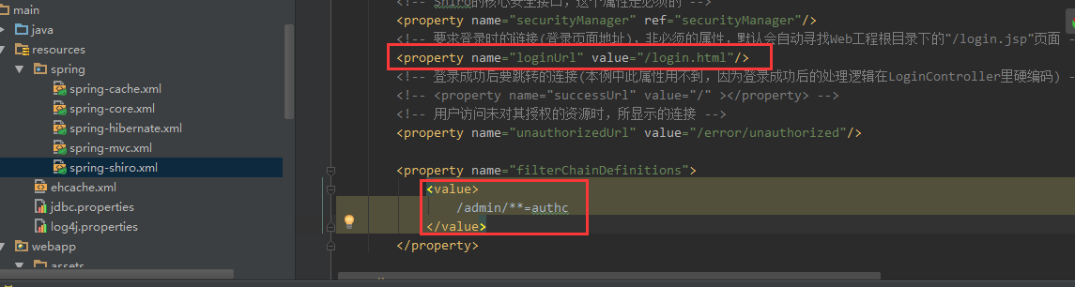

当我们输入一个需要登陆的页面时直接跳转到登录页面，而登录成功后跳转到刚才输入的地址，如下



控制逻辑

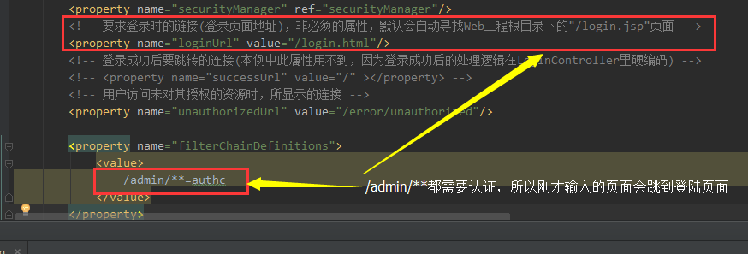

跳转逻辑

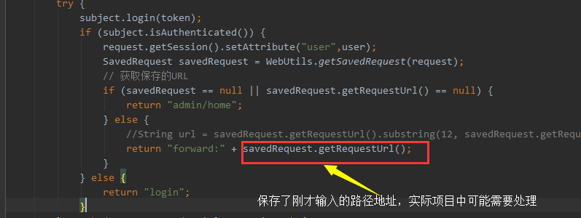

**授权测试**

管理员jacky登录



普通用户cheng登录



分析

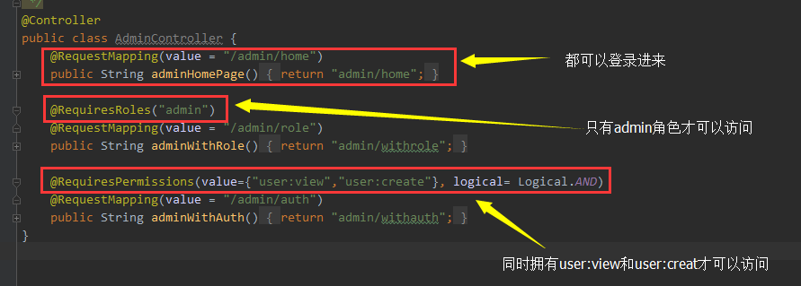

修改权限为只要一个满足就可以，那么cheng，也就可以访问那个权限页面

@RequiresPermissions(value={"user:view","user:create"}, logical= Logical.OR)

@RequestMapping(value = "/admin/auth")

public String adminWithAuth(){

return "admin/withauth";

}

* 1
* 2
* 3
* 4
* 5



**Shiro标签测试**

现在cheng和jacky都可以访问权限页面了

我们通过Shiro标签来让admin权限的用户可以创建用户，查看用用   
而user权限的只能查看用户



具体的授权标签

<shiro:hasRole name="admin">

<a href="user/show">查看用户</a><br>

<a href="user/create">创建用户</a>

</shiro:hasRole>

<shiro:hasRole name="user">

<a href="user/show">查看用户</a>

</shiro:hasRole>

* 1
* 2
* 3
* 4
* 5
* 6
* 7
* 8

需要引入

<%@ taglib prefix="shiro" uri="http://shiro.apache.org/tags" %>

* 1
* 2

好了，Shiro与SpringMVC的整合，数据库的连接，Shiro注解以及Shiro标签就介绍到这里

项目下载地址

<http://download.csdn.net/detail/frankcheng5143/9457411>